Svn installation and configuration

**Step 1 – Install Apache**

First of all, you need to install the Apache webserver to access the svn server using HTTP URLs. Skip this step if you already have Apache web server on your system.

sudo apt-get update

sudo apt-get install apache2

## Step 2 – Install SVN Server

Use the following command to install subversion packages and their dependencies. Also, install svn module for Apache libapache2-mod-svn packages on your system.

sudo apt-get install subversion libapache2-mod-svn libapache2-svn libsvn-dev

After installation, enable required Apache modules and restart Apache service

sudo a2enmod dav dav_svn

sudo service apache2 restart

## Step 3 – Create First SVN Repository

Use the following commands to create your first svn repository with name **myrepo**. Also, set the required permissions on newly created directories

sudo mkdir -p /var/lib/svn/

sudo svnadmin create /var/lib/svn/myrepo

sudo chown -R www-data:www-data /var/lib/svn

sudo chmod -R 775 /var/lib/svn

## Step 4 – Create Users for Subversion

Now create first svn user in **/etc/apache2/dav_svn.passwd** file. These users will use for authentication of svn repositories for checkout, commit processes.

sudo touch /etc/apache2/dav_svn.passwd

sudo htpasswd -m /etc/apache2/dav_svn.passwd admin

for create user with password

sudo htpasswd -b /etc/apache2/dav_svn.passwd admin admin

To create additional users, use following commands.

sudo htpasswd -bm /etc/apache2/dav_svn.passwd user1 user1

## Step 5 – Configure Apache with Subversion

Subversion Apache module package creates an configuration file **/etc/apache2/mods-enabled/dav_svn.conf**. You just need to make necessary changes to it.

sudo vi /etc/apache2/mods-enabled/dav_svn.conf

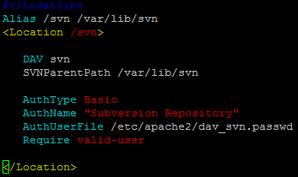

## Step 6 – Access Repository in Browser

<http://3.84.116.149/svn/myrepo/>

